Please use this link: https://uk.indeed.com/cmp/Chec-15df6d8a/reviews
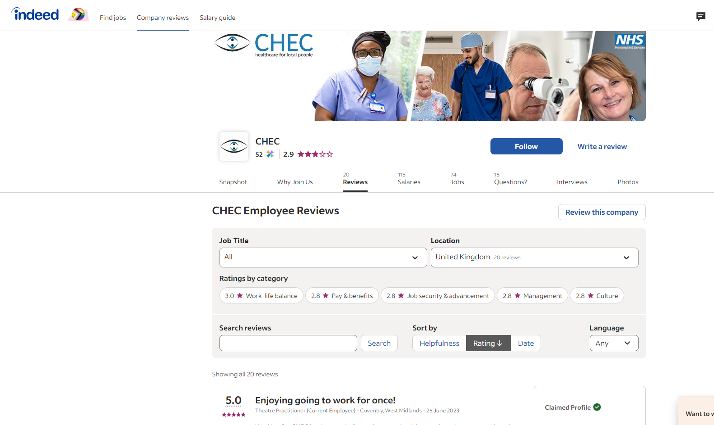
You will see this page!

Click “Review this company”:
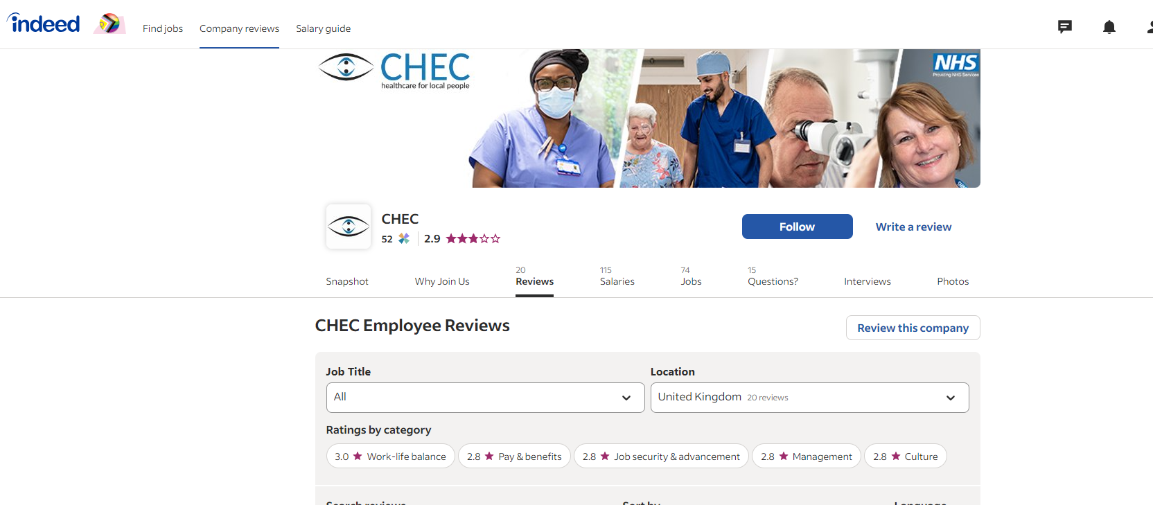
CLICK HERE

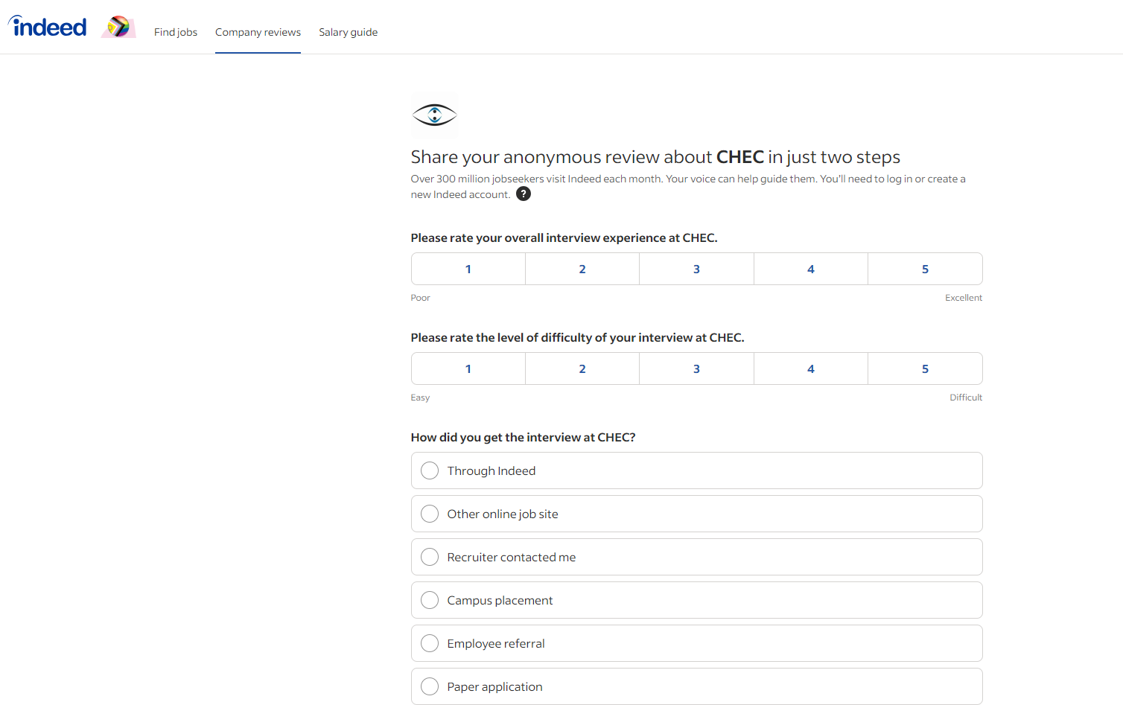
You will see this page!
Click through the options to start giving your review
After completing this section you can move onto the next section to write your review:
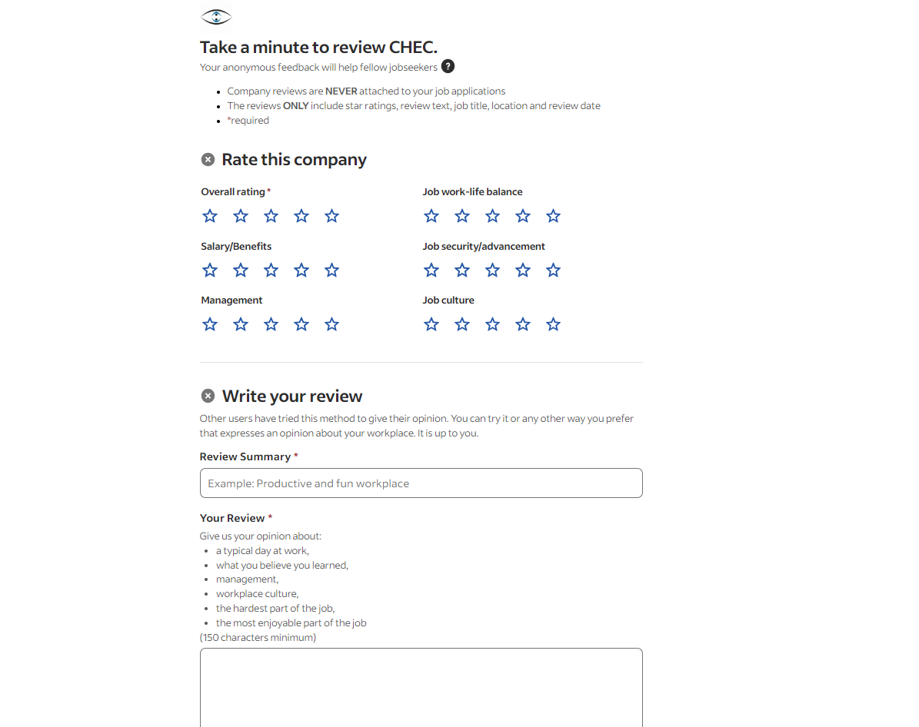
You must write at least 150 characters to move on to the next section
Examples of what to include in your review
‘Overall rating’, ‘Review Summary’ and ‘Your Review’ must be completed to move onto the next section
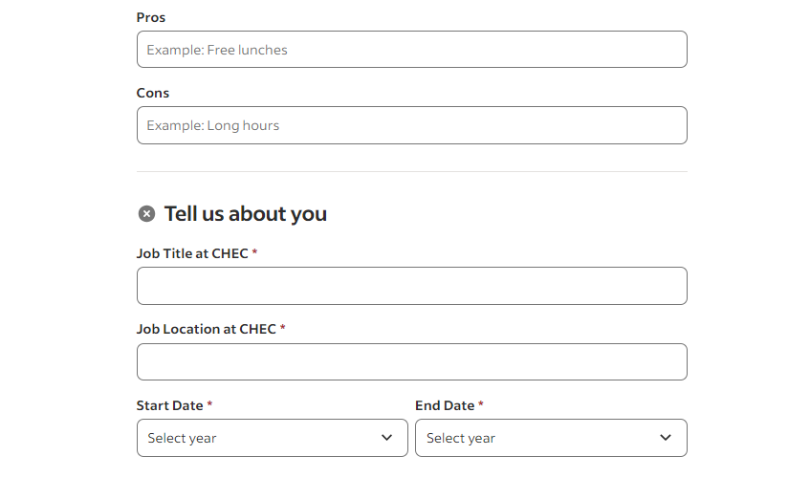
You can fill in the pros and cons of the job if you like, but it is not essential to move on to the next stage
Enter your Job Title and the location you are based at.
Also your start date and end date.
There is the option to say ‘I currently work here’.

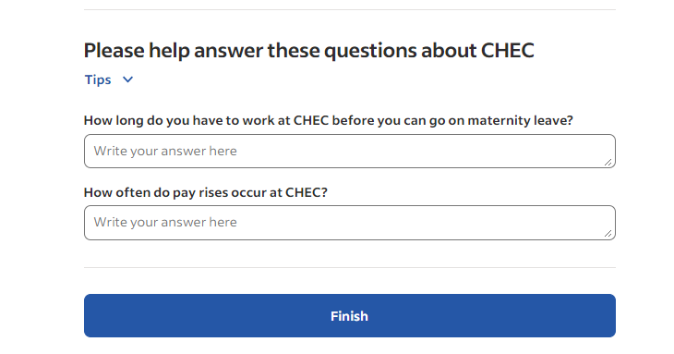
You will also be asked to answer some frequently asked questions, however this is optional and there is no need to answer these questions before moving onto the next stage
CLICK HERE TO PREVIEW YOUR REVIEW!

Once you have selected “Finish” your review it will appear on our Indeed webpage.
Thank you for taking your time to review CHEC on Indeed!

