Glassdoor Review Guide

Congratulations! We wish you the very best with your new role.
Let us know how you feel the recruitment process was below:
Glassdoor - Get Hired. Love Your Job | Glassdoor

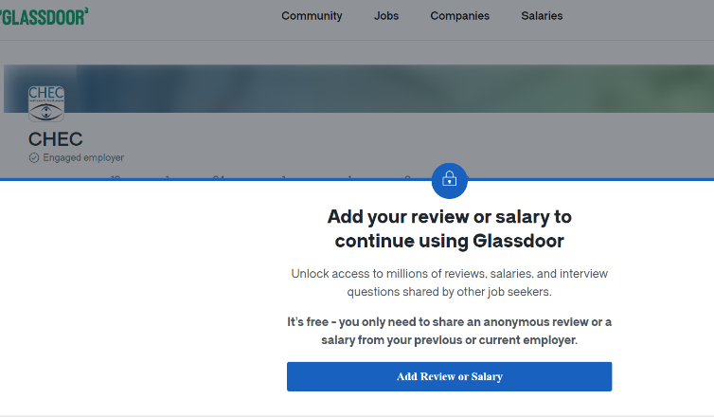
- Create or login to your account.

- Add CHEC to the company you would like to review.
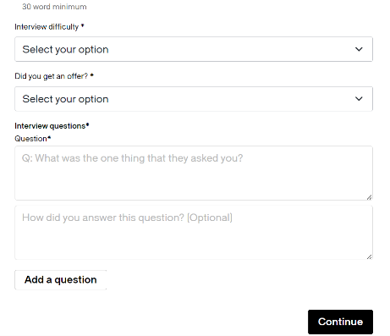
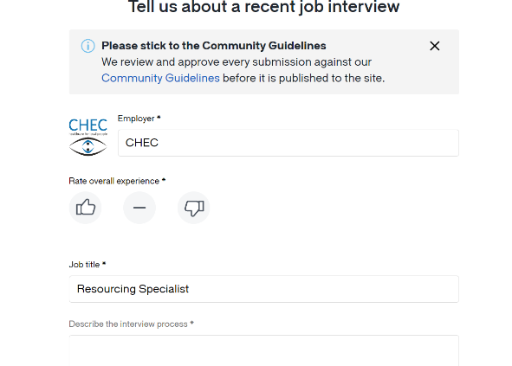
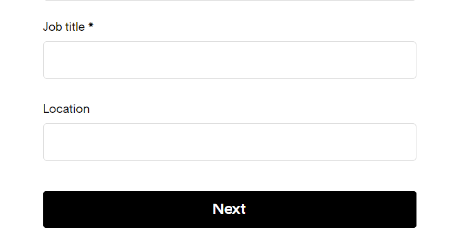
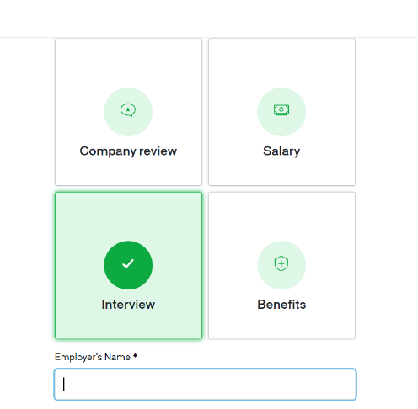
- Describe how you feel the initial screening call was and then how the interview process was.

- Be honest and let us know if you have any thoughts or feedback for us!
- Select which type of review you would like to leave.

- Fill in our details, the job title you interviewed for and the location you applied for.

